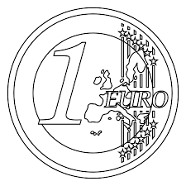

E

DÚHOVÉ PÍSMENO

E

OBŤAHOVAŤ

E E E E E E E E E E E E E E E E E E E E E E E E

STRIHAŤ

|  |  |  |  |  |  |  |  |
| --- | --- | --- | --- | --- | --- | --- | --- |
| E | E | E | E | E | E | E | E |
| E | E | E | E | E | E | E | E |
| E | E | E | E | E | E | E | E |
| E | E | E | E | E | E | E | E |
| E | E | E | E | E | E | E | E |
| E | E | E | E | E | E | E | E |
| E | E | E | E | E | E | E | E |
| E | E | E | E | E | E | E | E |
| E | E | E | E | E | E | E | E |
| E | E | E | E | E | E | E | E |

ČÍTAŤ

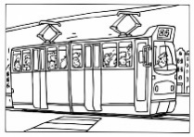

**E**LEKTRIČKA

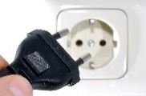

**E**LEKTRIKA



**E**URO

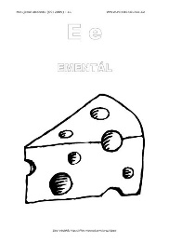

**E**MENTÁL

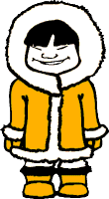

**E**SKIMÁK

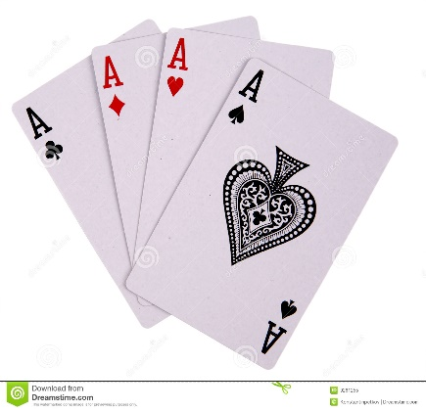

**E**SO

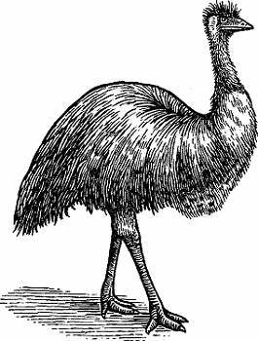

**E**MU

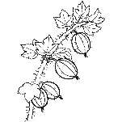

**E**GREŠ



**E**MAIL

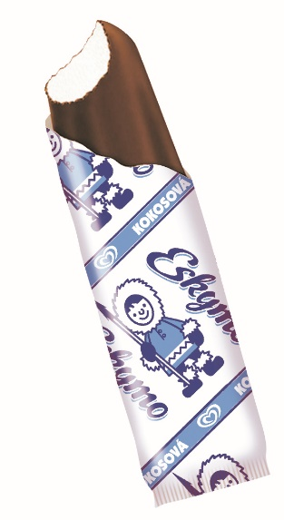

**E**SKIMO

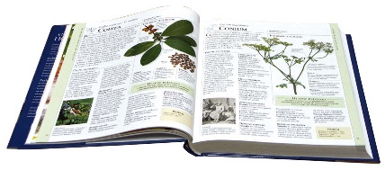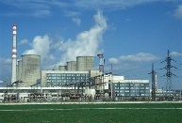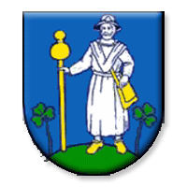

**E**NCYKLOÉDIA

**E**LEKTRÁREŇ

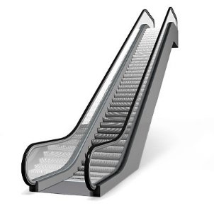

**E**SKALÁTOR

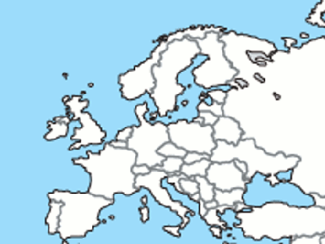

**E**URÓPA

**E**RB

LEPIŤ – PEČIATKOVAŤ





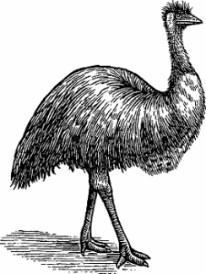











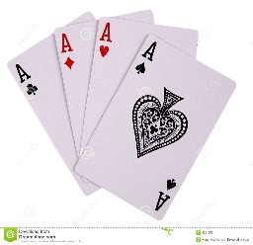

LEPIŤ – PEČIATKOVAŤ

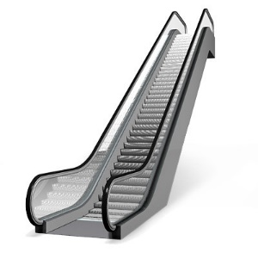















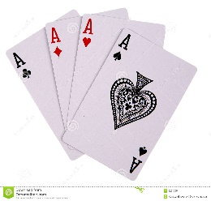

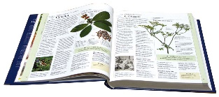

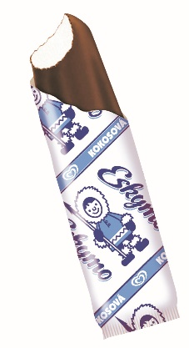



LEPIŤ – PEČIATKOVAŤ

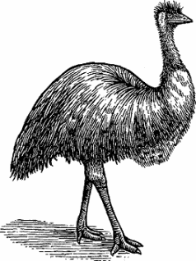



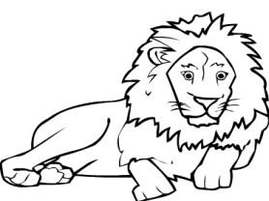

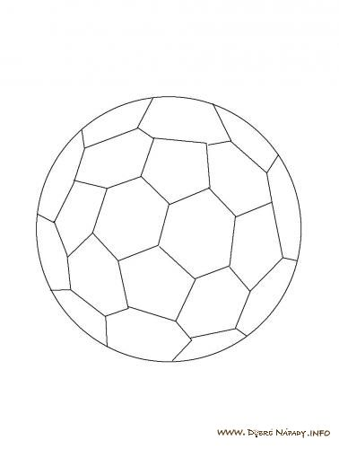

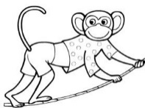

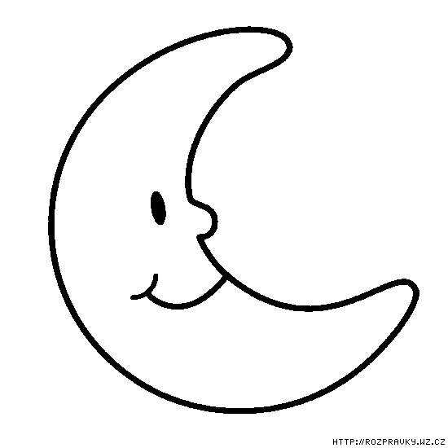

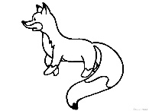

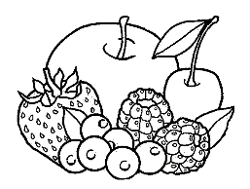





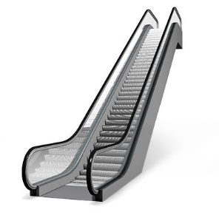

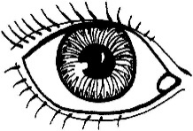

LEPIŤ – PEČIATKOVAŤ

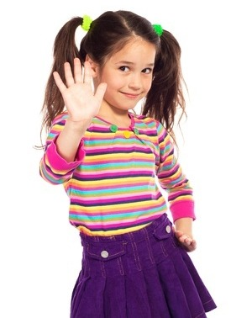

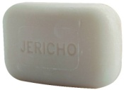

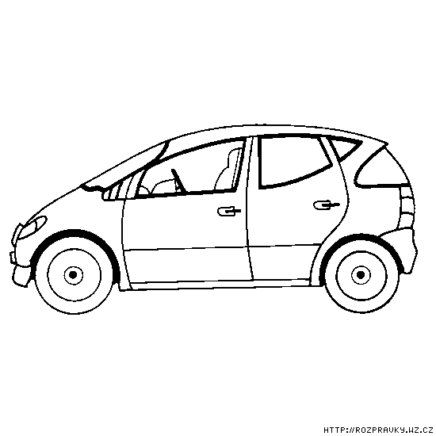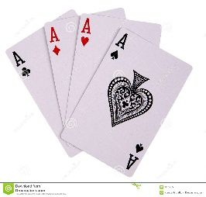

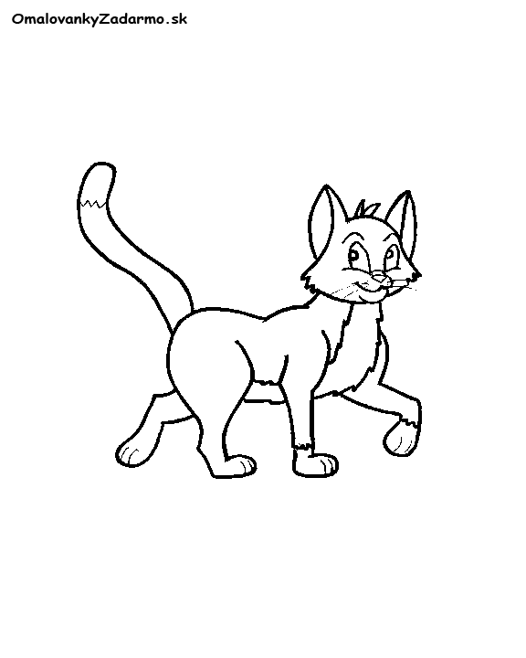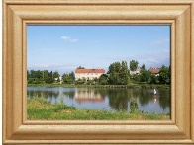

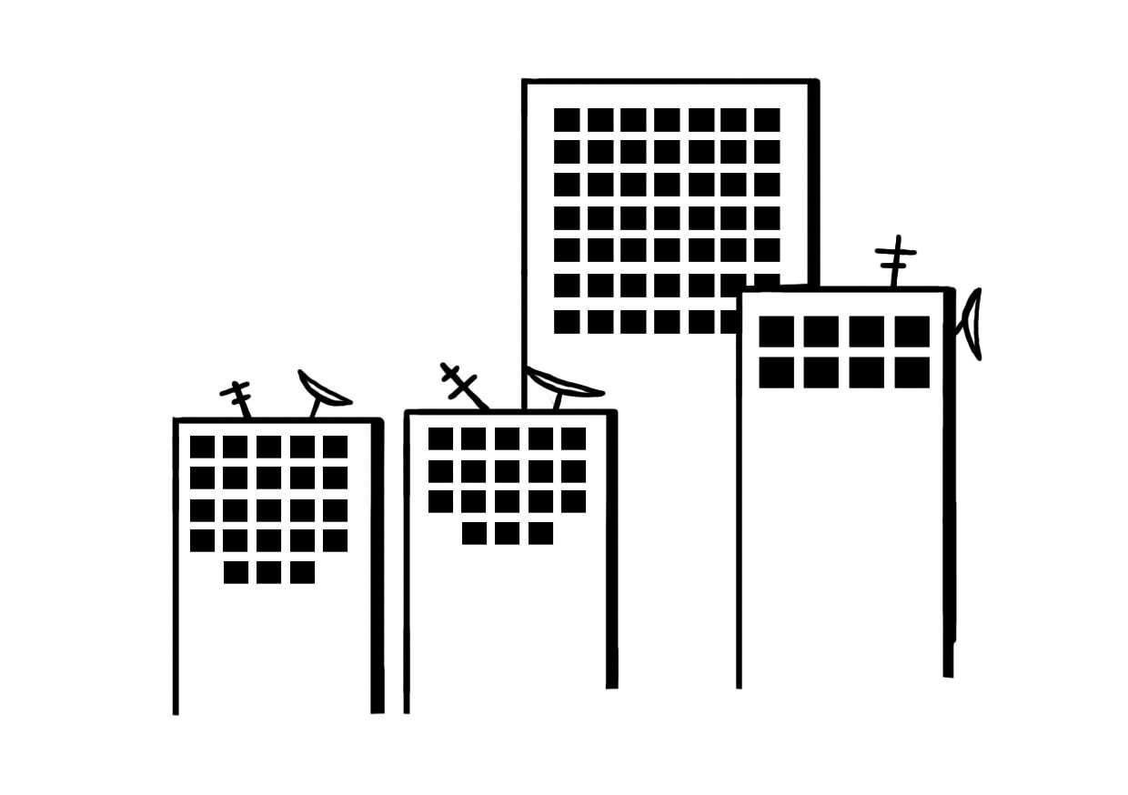

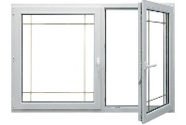







E

E U I E R D F E O P E D V G E R K L O A M E I S X C E E I O A M P L S

E

S A E R T U I O PE E D C E I K L O E S X C E W Q E T P S A V B M L O P I E W S E R M O L A S D E P E E S E P O L E E R T U O P Y E M E R L O M E D R S P O L A M E O E L E

E – MODROU

|  |  |  |  |  |  |  |  |
| --- | --- | --- | --- | --- | --- | --- | --- |
| R | U | E | S | E | O | P | E |
| N | K | L | O | E | S | X | D |
| E | A | S | T | E | V | E | E |

E – MODROU

|  |  |  |  |  |  |  |  |
| --- | --- | --- | --- | --- | --- | --- | --- |
| P | E | V | E | A | S | E | N |
| J | U | I | O | E | R | D | C |
| M | K | O | E | R | E | O | P |
| L | E | S | A | E | X | Q | E |
| T | B | E | E | I | O | E | M |

VYTLIESKAŤ

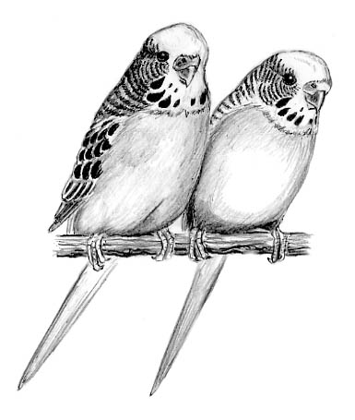

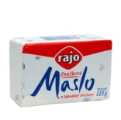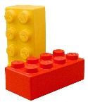

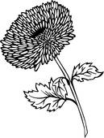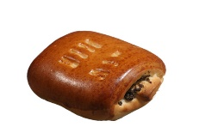

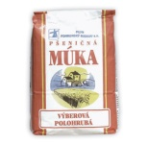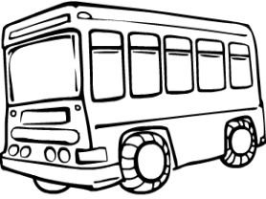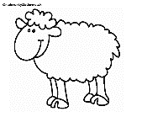

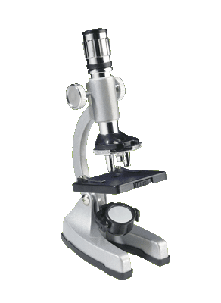

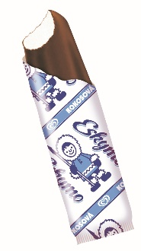

E – MODROU

L – ČERVENOU

|  |  |  |  |  |  |  |  |
| --- | --- | --- | --- | --- | --- | --- | --- |
| E | O | H | N | D | E | L | P |
| A | L | E | D | L | R | C | S |
| W | E | L | E | O | L | P | L |

E – MODROU

M – ČERVENOU

|  |  |  |  |  |  |  |  |
| --- | --- | --- | --- | --- | --- | --- | --- |
| R | M | J | S | E | D | N | M |
| K | E | D | O | K | E | D | E |
| M | M | O | A | E | P | E | D |
| X | E | M | J | E | D | P | L |

OBŤAHOVAŤ

O  E L  A E

A  M L E M

L M O E A

A  E M A O

E – MODROU L – ZELENOU

O – ČERVENOU

|  |  |  |  |  |  |  |  |
| --- | --- | --- | --- | --- | --- | --- | --- |
| E | O | A | L | E | L | P | O |
| L | D | E | S | L | O | H | O |
| F | O | G | E | E | J | L | E |

E – MODROU M – ZELENOU

O – ČERVENOU A – ŽLTOU

|  |  |  |  |  |  |  |  |
| --- | --- | --- | --- | --- | --- | --- | --- |
| E | M | O | M | S | E | A | O |
| A | M | E | D | A | O | M | K |
| E | E | P | M | R | E | O | A |
| O | E | A | C | V | A | T | B |
| E | O | E | M | G | E | E | M |

SPÁJAŤ





E

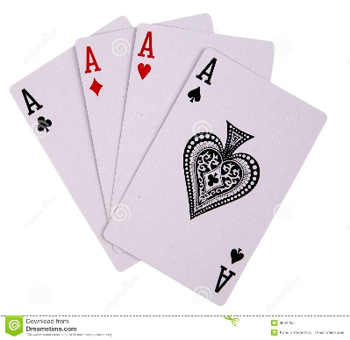







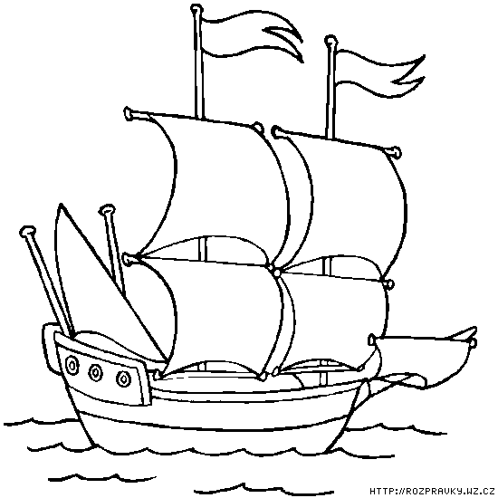SPÁJAŤ

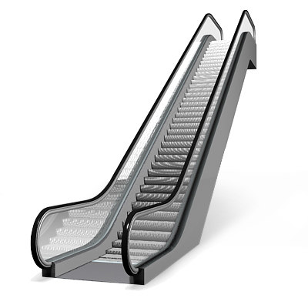



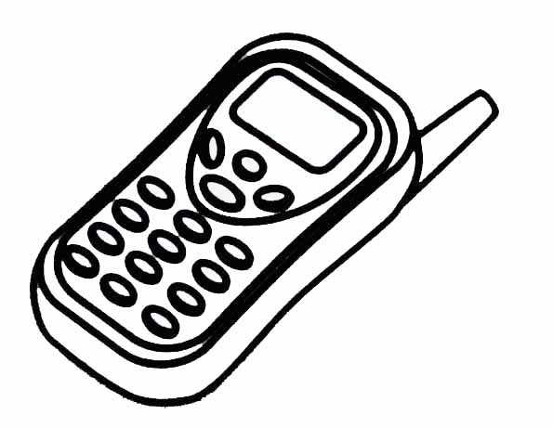

E

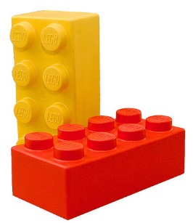

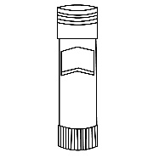





L

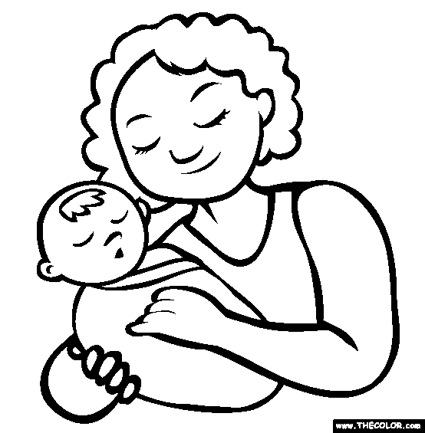

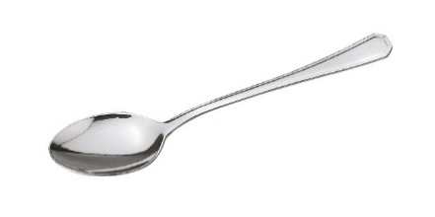

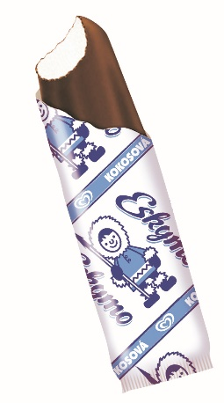





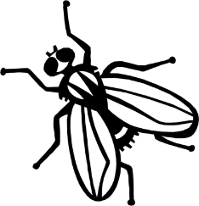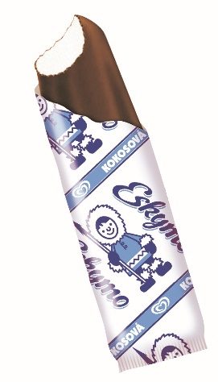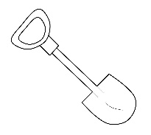SPÁJAŤ

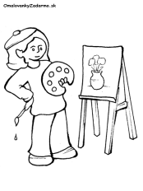

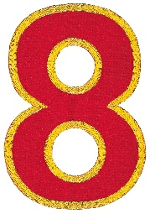

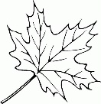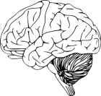

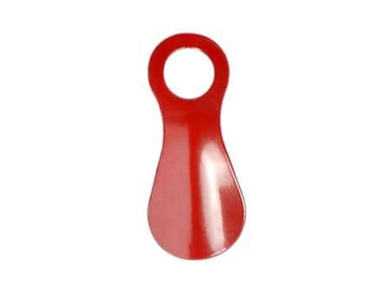

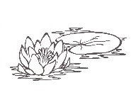

O

M

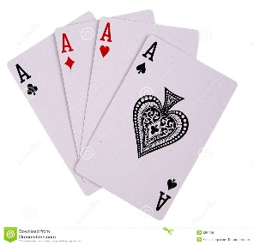

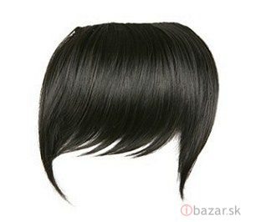

E

L



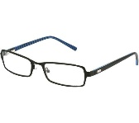



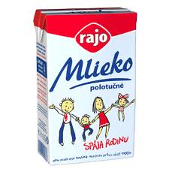

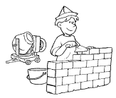

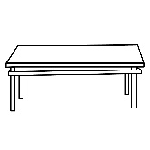

ČÍTAŤ

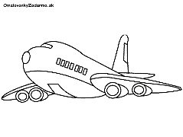

**A A**

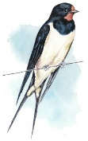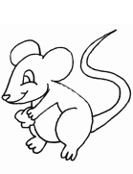

**A A**





**A**

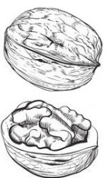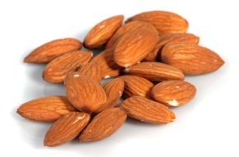ČÍTAŤ

**A A**

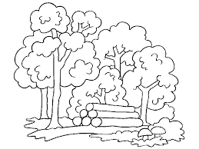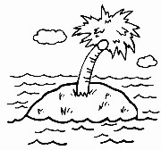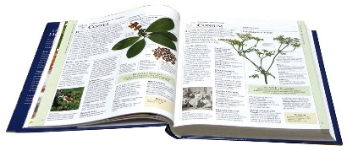

**A A**

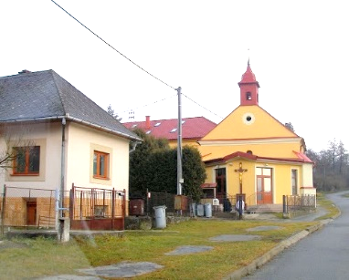

**A**



**O**



**O**



**O A**

E – MODROU M – ZELENOU

A – ČERVENOU L – ŽLTOU

|  |  |  |  |  |  |  |  |
| --- | --- | --- | --- | --- | --- | --- | --- |
| L | M | A | E | V | A | L | M |
| A | D | E | M | E | S | E | K |
| E | P | L | E | I | A | S | L |

E – MODROU M – ZELENOU

A – ČERVENOU L – ŽLTOU

|  |  |  |  |  |  |  |  |
| --- | --- | --- | --- | --- | --- | --- | --- |
| A | M | L | E | S | A | O | E |
| L | E | A | O | M | E | L | M |
| M | D | E | B | N | M | E | L |
| M | E | Q | O | M | K | L | A |

ČÍTAŤ

|  |  |  |  |  |  |  |
| --- | --- | --- | --- | --- | --- | --- |
| E | A | M | O | L | E | L |

|  |  |  |  |  |  |
| --- | --- | --- | --- | --- | --- |
| O | M | L | E | A | M |
| E | O | E | A | M | L |

ČO JE NA ZAČIATKU?



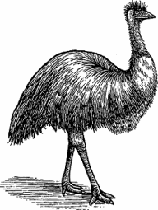

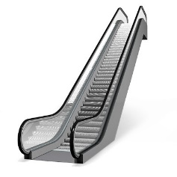

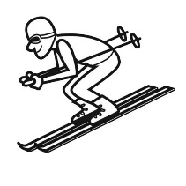







ČO JE NA ZAČIATKU?

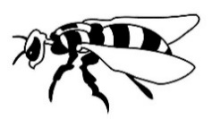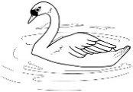



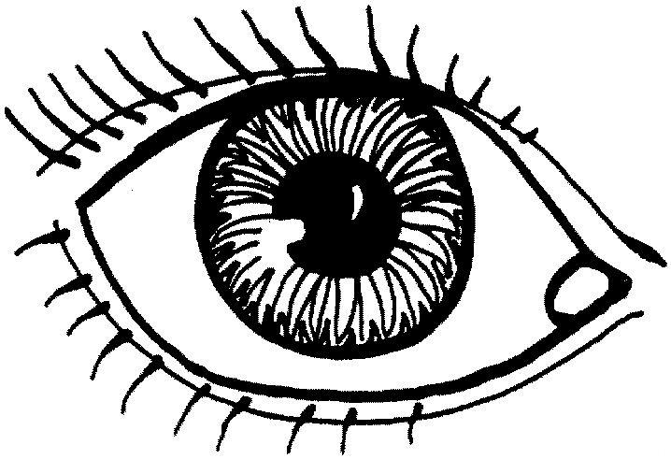

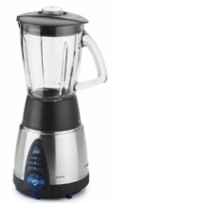

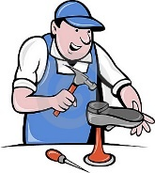



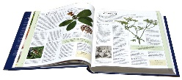



ČO JE NA ZAČIATKU?



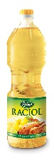



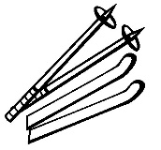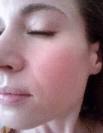

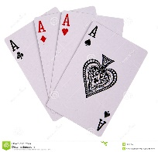

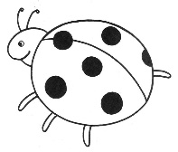

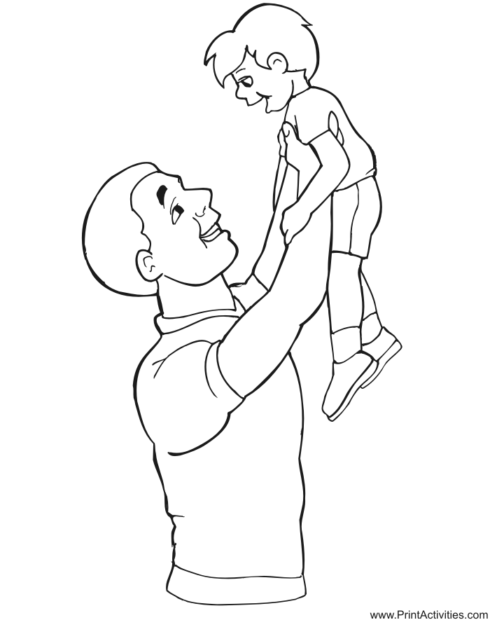

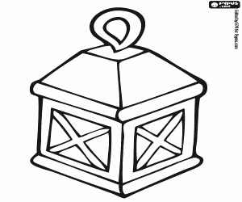

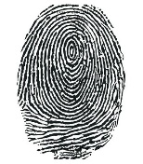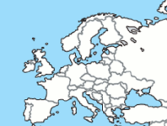

 ČO JE NA ZAČIATKU?

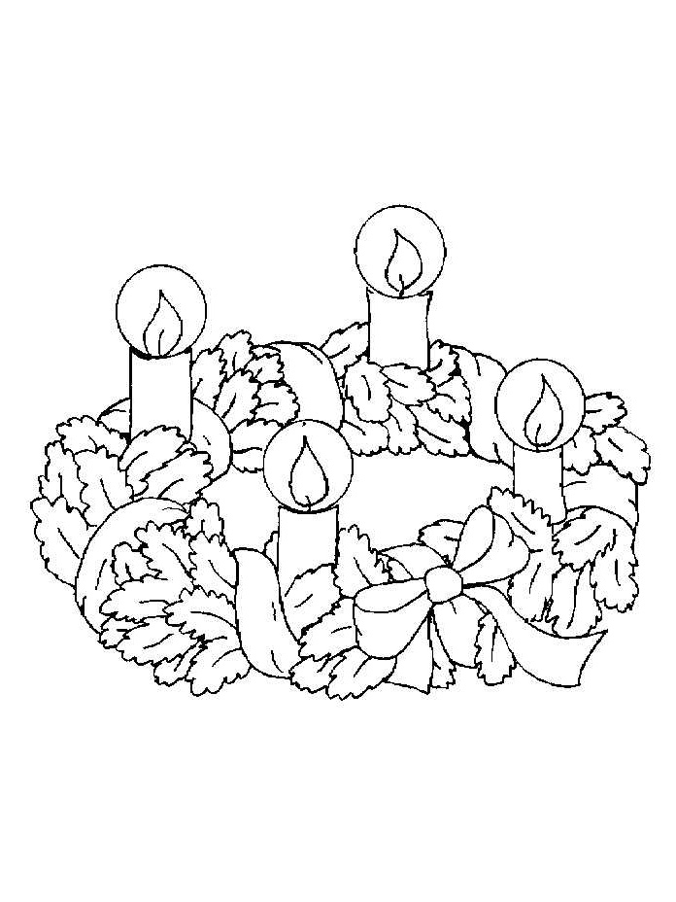

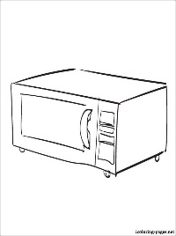

|  |  |  |  |  |
| --- | --- | --- | --- | --- |
|  |  |  |  |  |

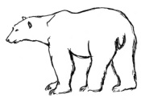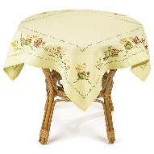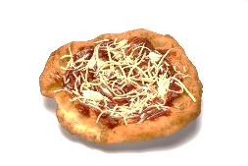

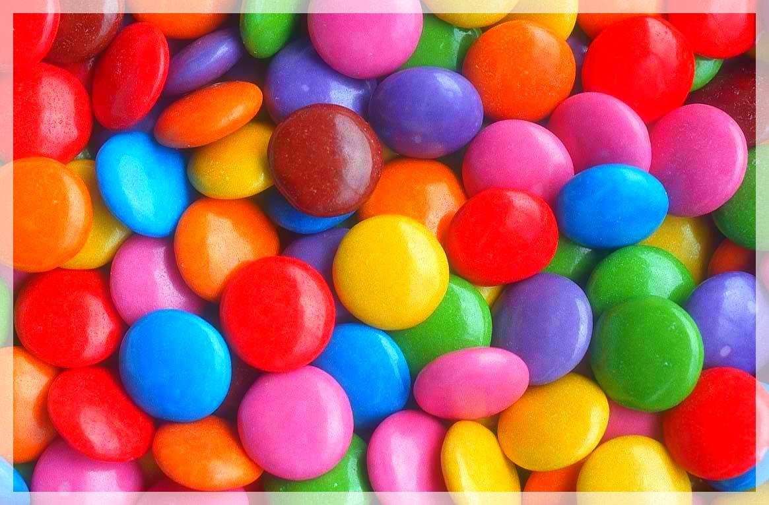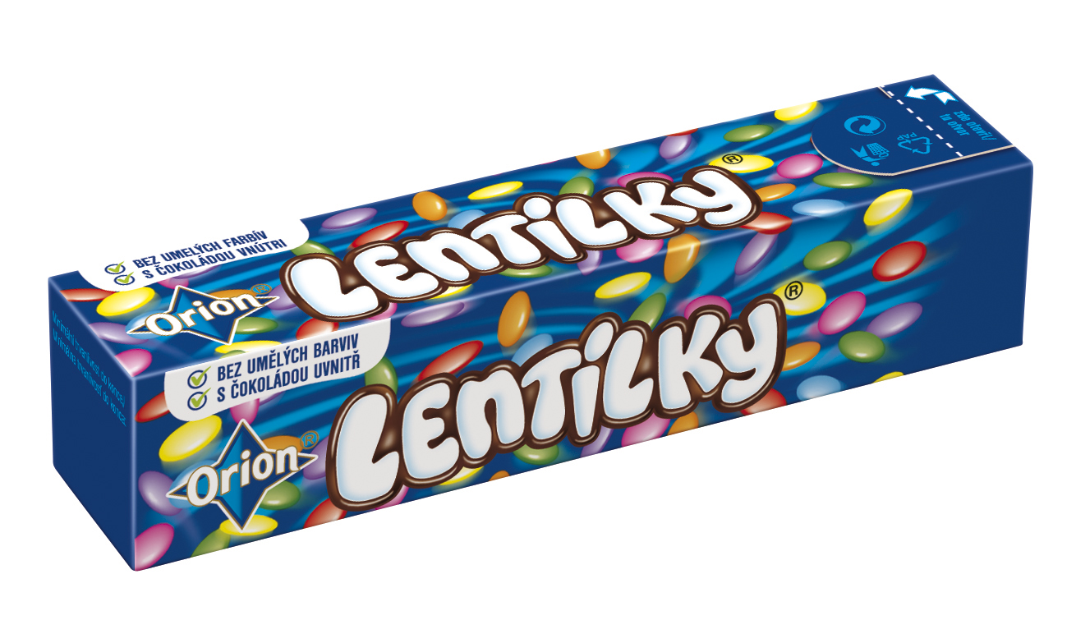

|  |  |  |  |  |
| --- | --- | --- | --- | --- |
|  |  |  |  |  |

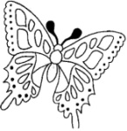

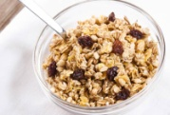

|  |  |  |  |  |
| --- | --- | --- | --- | --- |
|  |  |  |  |  |

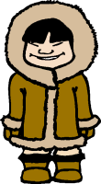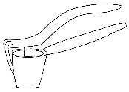

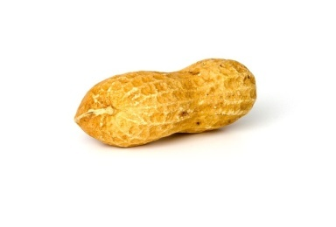

|  |  |  |  |  |
| --- | --- | --- | --- | --- |
|  |  |  |  |  |

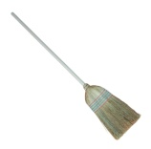SPÁJAŤ

A



M

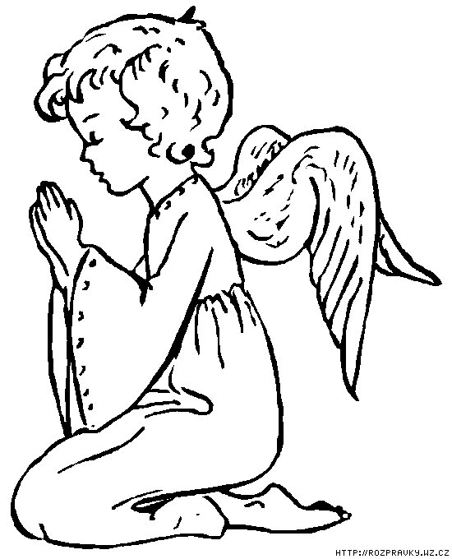

O

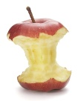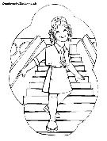

L

E

L

O

M

A

E

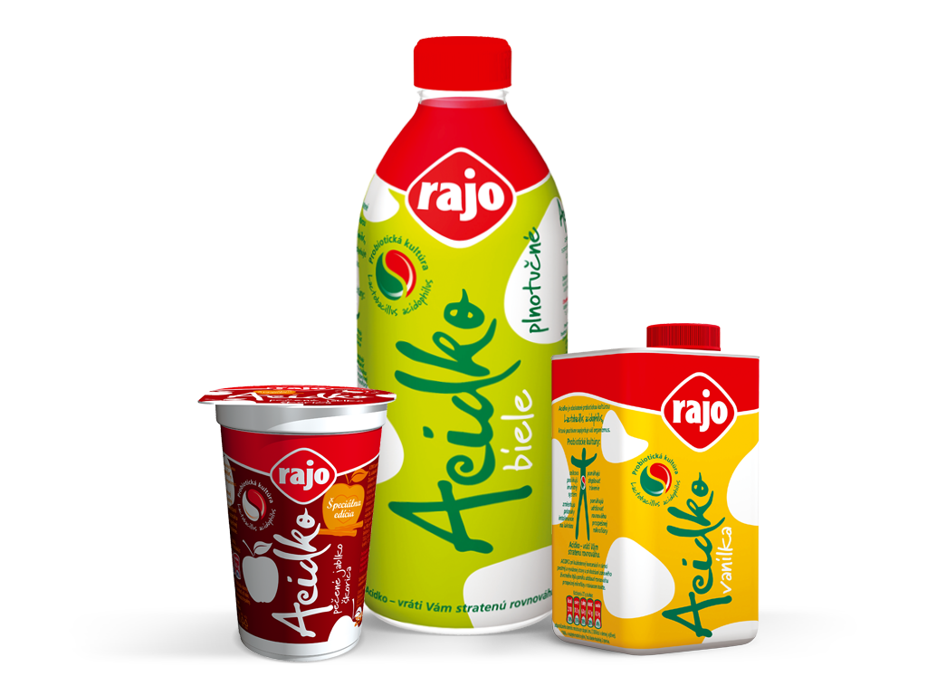



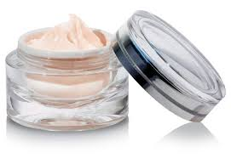

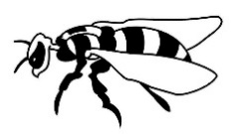SPÁJAŤ

L



E





O

E

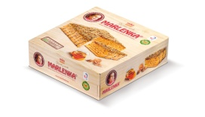

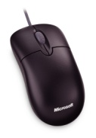

L

M

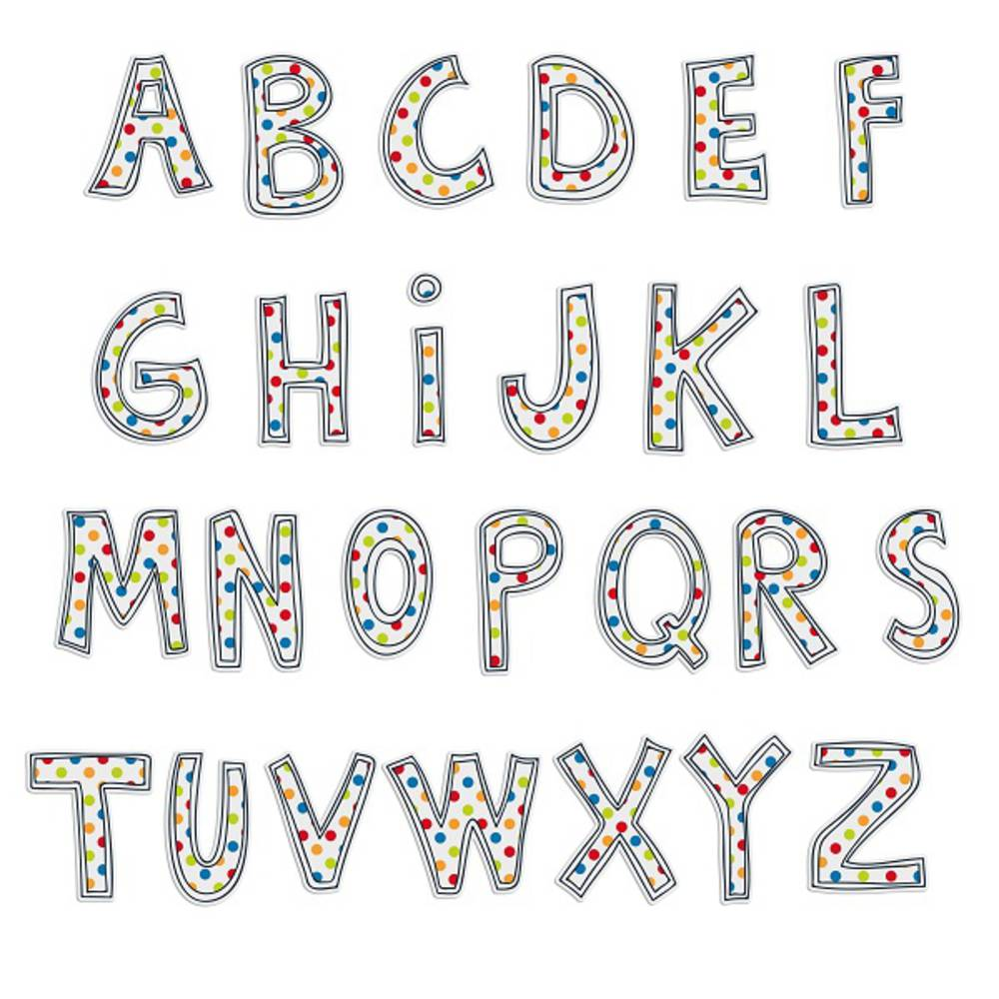

O



A

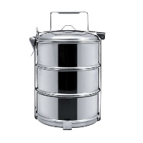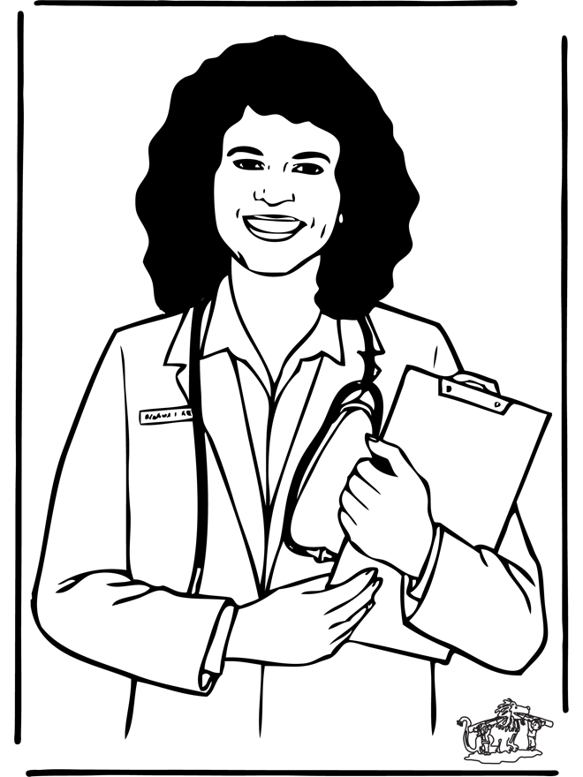

M

A

ČÍTAŤ

|  |  |  |  |  |  |
| --- | --- | --- | --- | --- | --- |
| M | O | L | A | E | L |
| E | O | L | E | A | M |

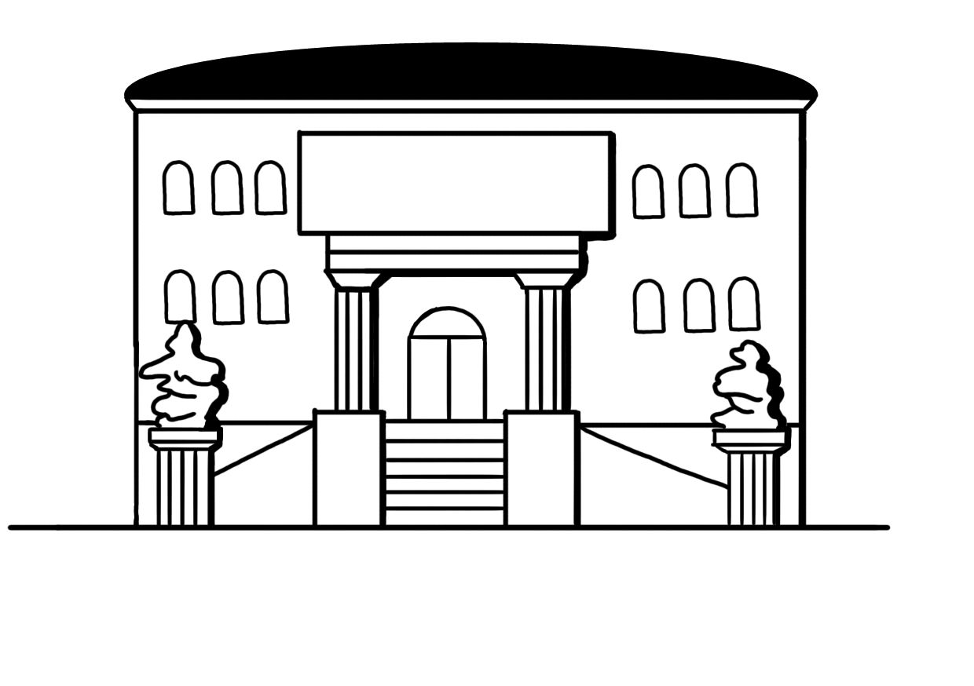VYTIESKAŤ

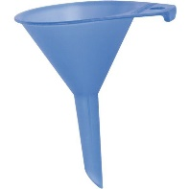



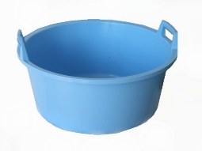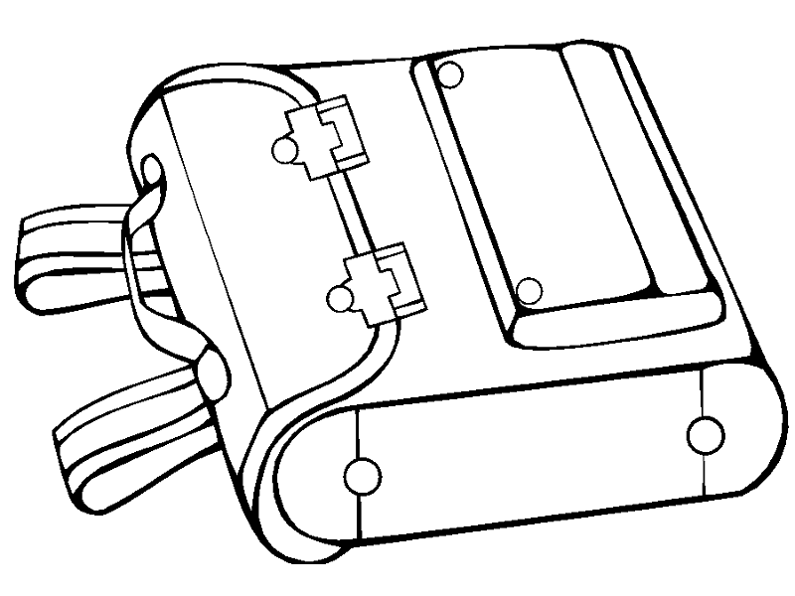

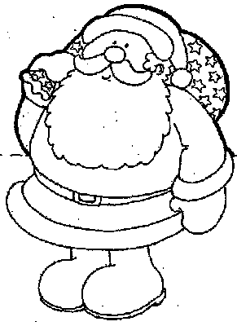

SPÁJAŤ ROVNAKÉ

M E A L O

E M L O A

M O E L A

O  M A E L

M O E L A

M L E O A

SPÁJAŤ ROVNAKÉ

E L

M O

L M

O E

A E

L L

M O

O M

E A

PÍSAŤ - VYFARBIŤ



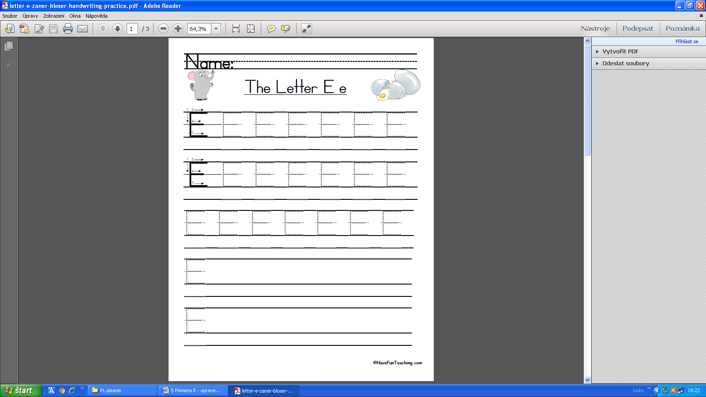

LEPIŤ – PEČIATKOVAŤ

|  |  |  |  |  |  |
| --- | --- | --- | --- | --- | --- |
| A | O | L | E | M | A |
|  |  |  |  |  |  |
| L | E | E | M | O | L |
|  |  |  |  |  |  |
| M | E | A | A | O | E |
|  |  |  |  |  |  |
| E | L | M | E | M | A |
|  |  |  |  |  |  |
| O | M | O | L | E | M |
|  |  |  |  |  |  |

VYTLIESKAŤ, SPOJIŤ

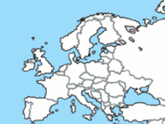







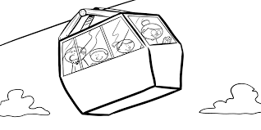



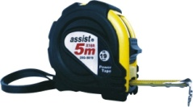

PÍSAŤ

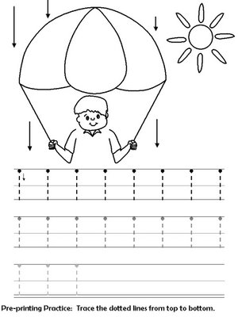

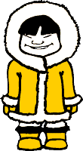

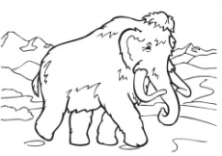LEPIŤ – PEČIATKOVAŤ – ČÍTAŤ

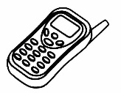

|  |  |
| --- | --- |
| MA | |
| M | A |
|  |  |
|  | |

|  |  |
| --- | --- |
| MO | |
| M | O |
|  |  |
|  | |

|  |  |
| --- | --- |
| ME | |
| M | E |
|  |  |
|  | |

|  |  |
| --- | --- |
| LA | |
| L | A |
|  |  |
|  | |



|  |  |
| --- | --- |
| LE | |
| L | E |
|  |  |
|  | |

|  |  |
| --- | --- |
| LO | |
| L | O |
|  |  |
|  | |

