Eggciting time ahead of us
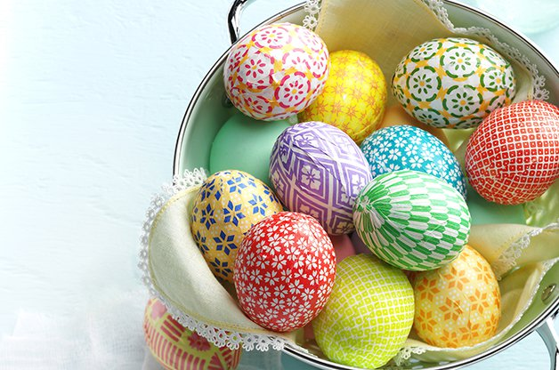
Spring is finally here and we can start enjoying all the great things this season brings- a lot more sunshine, bird sounds, green pastures/ˈpɑːstʃə(r)/...and many more. This year, however, April`s going to be truly EGGciting. It`s Easter after all!
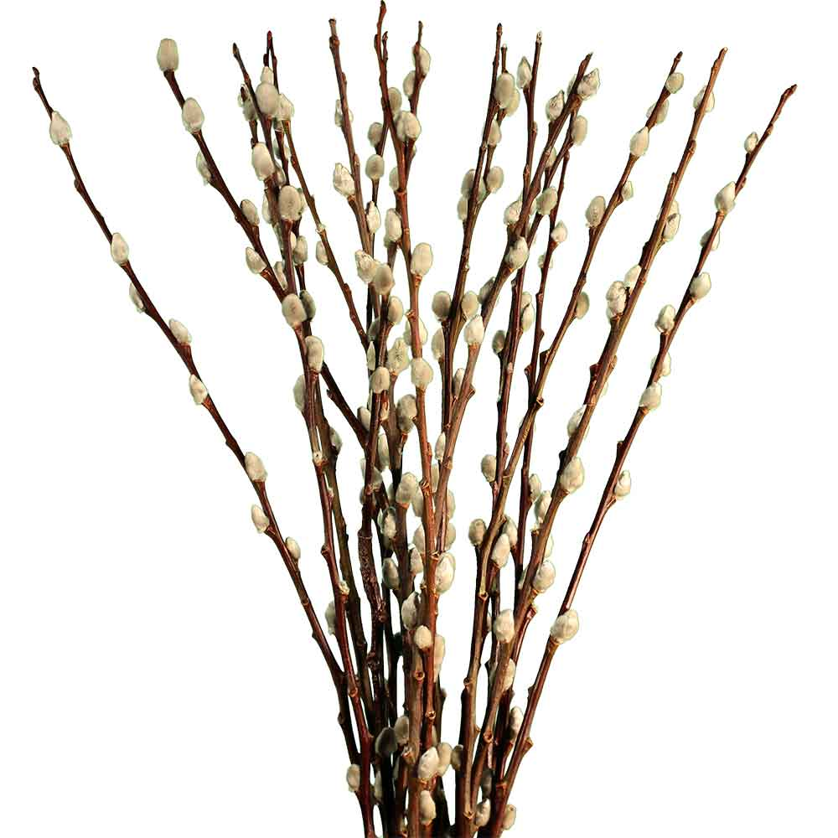
Although Easter has got its religious tradition, it`s also fun. With all those willow /ˈwɪləʊ/ whips/wɪp/ and buckets of water it can`t be different. It`s a sweet, colourful, painful and wet holiday. Definitely wet! And definitely eggciting! Eggs are practically everywhere. Some days before Easter, girls decorate them. Chicken eggs. Goose eggs. Quail /kweɪl/ eggs. You may paint them all. After that, girls hang them on willow branches /brɑːntʃ/ in a vase, or they give them to those men who come to whip them.
Many cultures believe eggs to be the source of new life. In ancient Egypt, an egg was respected as the origin of the world. In China, painted eggs were given as a gift. In ancient Greece and Rome, people celebrated the spring equinox /ˈiːkwɪnɒks/ by hanging up colourful eggs. Christianity adopted eggs as a symbol of fertility /fɜː(r)ˈtɪləti/, resurrection/ˌrezəˈrekʃ(ə)n/ , and eternal life.
And because this language blog should teach you a bit of “out of textbook English” I told myself: “Let`s make this fully EGGISH.“
- Remember, you are not a good person if you EGG ON somebody → you encourage sb. to do something they should not do.
“He would never have stolen it if you hadn`t egged him on.“

- If you make your parents angry, start WALKING ON EGGS → when you walk on eggs, you act with great care and consideration not to upset somebody.

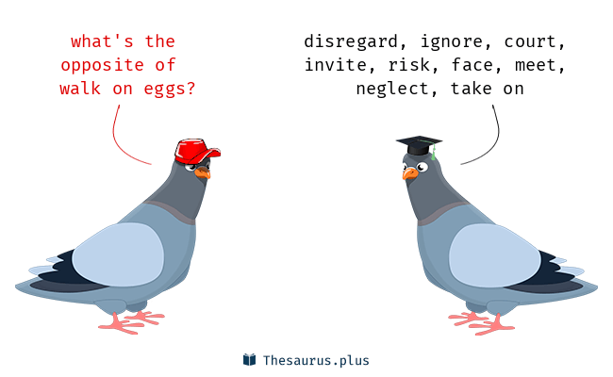
- And finally, don`t be the person who wants EGG IN THEIR BEER → egg in your beer is a bonus, something for nothing.
“ What do you want, egg in your beer?“ →a reaction you can use to talk to sb. who complains about something they should already be happy about.

pastviny
slovná prešmyčka: exciting-eggciting
willow= vŕba, whip= bič, v našom regióne a ponímaní to môžeme prekladať ako vŕbový korbáč
prepelica
vetvička
rovnodennosť
plodnosť
zmŕtvychvstanie

