And there we are again, so do it slowly...Biscuit or cookie?

And there we are again was the first phrase what was heard from my mouth when I entered to our school. Then I have decided that our first look to English language this school year will be gentle and I was curious why we have biscuits and cookies and why they can exist in vice versa but with different meanings. And I have chosen this issue, because almost every single of my students know that I love peculiarities of English used in gastronomy. It is very specific and fruitful sphere of language.

Biscuit or cookie?

“England and America are two countries divided by a common language.” so said George Bernard Shaw. Much has been written about words that are chiefly used in one country or the other (for example, eggplant in the US and aubergine in the UK), but there are also words that exist in both countries but have different meanings depending on which side of the Atlantic you are on, and it’s very possible to find yourself lost in translation if you don’t know the lingo.

Learning and listening to both Englishes, I am aware of how American English and British English are different, and it’s especially interesting when the difference is so subtle.

Biscuit

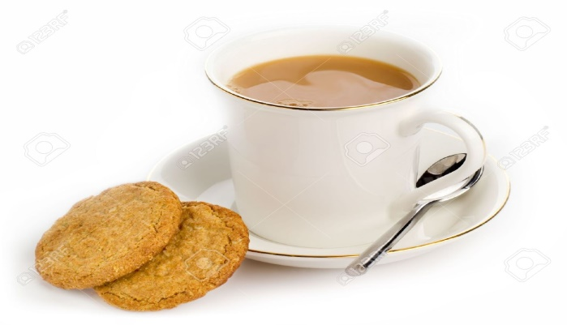

Let’s start with the biscuit. In the UK, your biscuit might be topped with chocolate or have

currants in it. You might dip it in your cup of tea, or have one (or two or maybe three) as a snack after lunch.

If you were in the US, however, you might put bacon and eggs on it or smother it in gravy and have it for breakfast. Or you might put a piece of chicken on it and have it for dinner.

Oxforddictionaries.com notes this difference, giving two definitions for the word. But how did these two very different meanings come to be? According to the Oxford English Dictionary, the word biscuit comes originally from the Latin biscotum (panem), which means bread ‘twice baked’, which would explain the hard, crunchy quality of a British biscuit.

An American biscuit is more like what the Brits would call a scone (and an American scone is something else entirely), and the pronunciation is another matter entirely. It’s unclear how these two different foods came to have the same word, and we can only speculate about the influence of the French language in the southern United States

Cookie

The word cookie opens up a whole other can of worms. In the UK, a cookie is a soft, moist biscuit (for lack of a better word). British cookies tend to be bigger and more substantial than a British biscuit.

In the US, a cookie covers both what the British would call a biscuit and a cookie. The word comes from the Dutch koekje, meaning ‘little cake,’ and could have been popularized in the US due to early Dutch colonization, though we don’t know for sure.
So you’ve got it, right? A British biscuit is an American cookie and an American cookie is a British cookie and an American biscuit is a British scone and an American scone 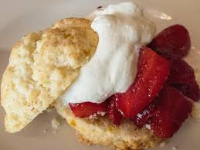
is something else entirely. You can see it on this picture with whipped cream and strawberries…Simple! Now, what would you like with your tea?

AMERICAN BISCUIT WITH GRAVY (very popular as breakfast meal or for brunch)
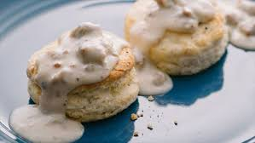

Cudzí jazyk
jemný
Hrozienka... Hoci sa skôr používa pre hrozienka výraz raisins a currant sú ríbezle.
Vo význame ďalší problém...Veľmi zaujímavá fráza v angličtine, tie nikdy neprestanú prekvapovať
vlhké
Omáčka, avšak gravy je na rozdiel od sauce robená z výpeku a ide o hustú ťažšiu omáčku, sauce je napr. rajčinová alebo soy sauce – sójová, ide skôr o studené než teplé omáčky.

