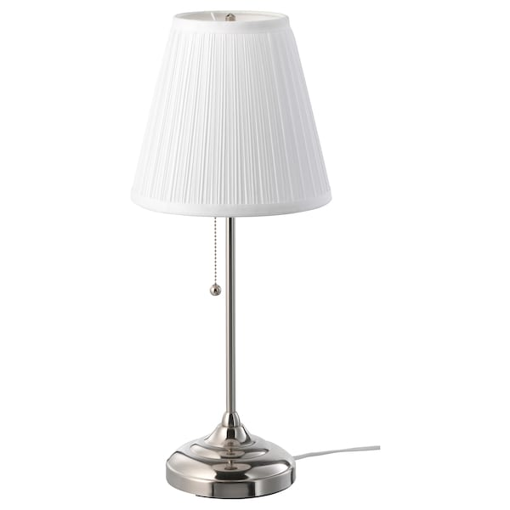

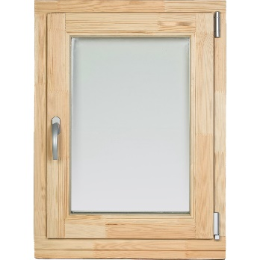

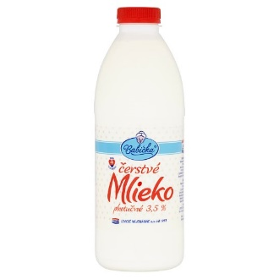

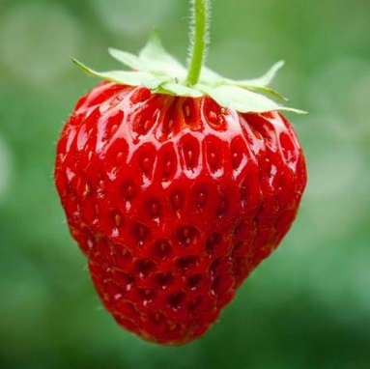

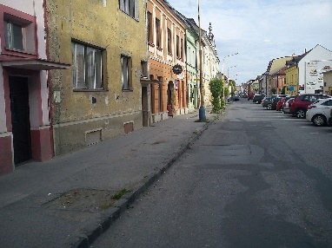
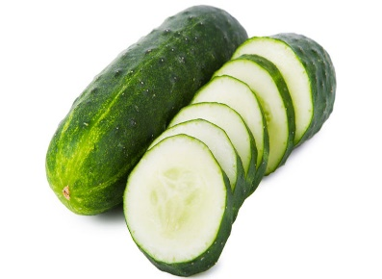
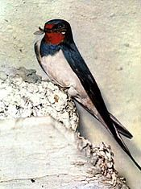

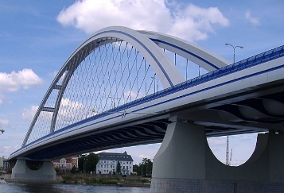

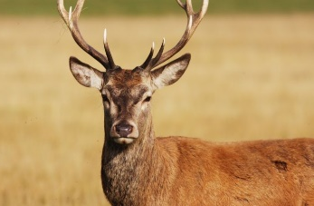

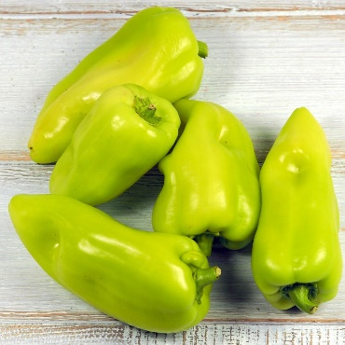

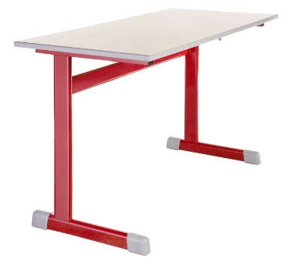
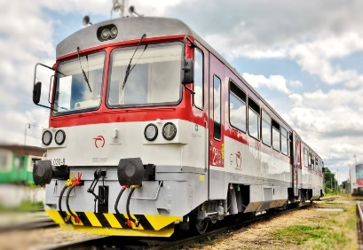

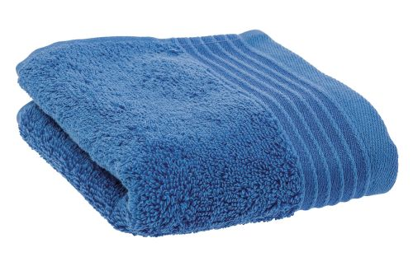

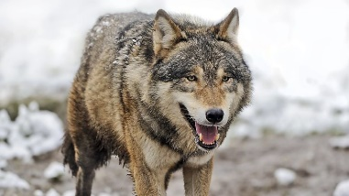

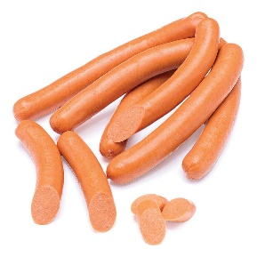
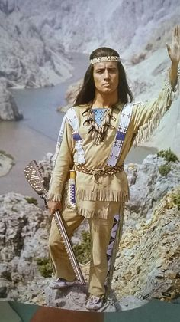
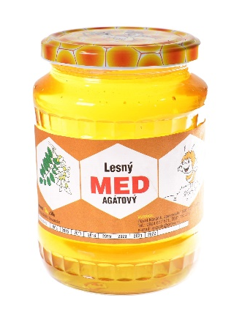

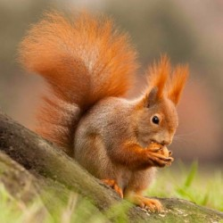

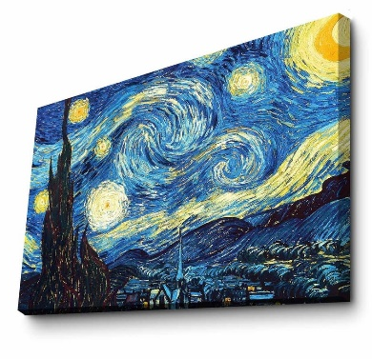
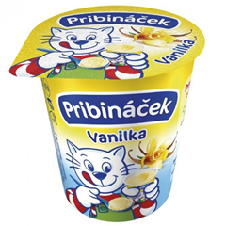
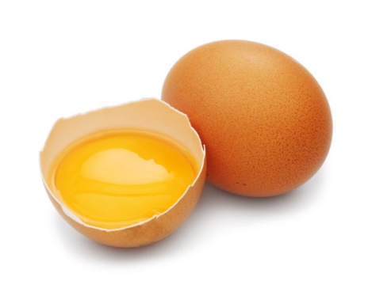

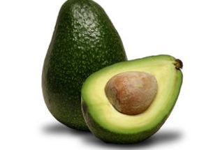

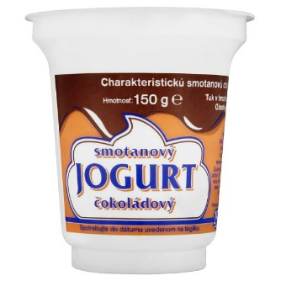

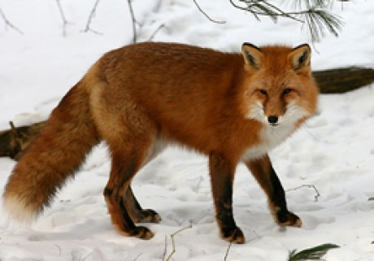

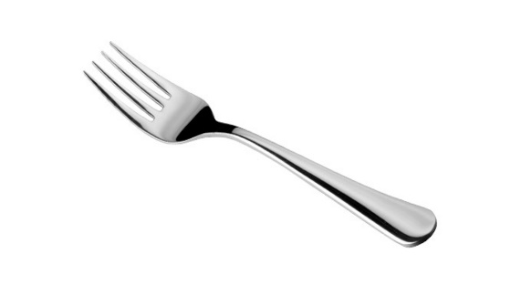

Zdroje obrázkov :
https://i.pinimg.com/originals/09/bf/9d/09bf9d2fd2f5bdb9443bed602d8af093.jpg
https://zena.pravda.sk/jedlo/clanok/483387-uhorka-zelenina-ktora-v-tele-robi-zazraky/
https://www.google.com/search?q=ulica&client=firefox-b-d&source=lnms&tbm=isch&sa=X&ved=2ahUKEwj9msbpyOjoAhXpShUIHZikDbMQ_AUoAXoECB8QAw&biw=1536&bih=740#imgrc=C4TTJth-5Sfk-M
https://www.knihcentrum.sk/magneticka-jahoda
https://potravinydomov.itesco.sk/groceries/sk-SK/products/2002121396176
https://www.ikea.com/sk/sk/images/products/arstid-table-lamp__0609332_PE684455_S5.JPG?f=s
https://cloudia.banoviny.sk/r770x433n/0c9cf0bce1e109c55d3937ce8da78d0e
https://www.kovovynabytok.sk/image/productgallery/1024x1024/14439.jpg
https://zahori.sk/wp-content/uploads/2017/04/zahoracik_vlak.jpg
https://products.kika-cdn.com/full/sk/5168828.jpg/
https://i.pinimg.com/236x/24/ef/55/24ef55bed948f548dc46d8b574cf5d19.jpg
https://images.obi.sk/product/AT/1500x1500/894253_1.jpg
https://lh3.googleusercontent.com/proxy/zTlazI9R06Q_C8jMZ1RA9EKVoxq3nKEtnbOafd9ti6NfyEauv6lHkPBiGeCskbm4ubBUKjXGS0bU6haTPXKUrrb9CP9hO5QO2_jkngUBZop1WwxHM9Gi
https://i.pinimg.com/originals/cd/79/c9/cd79c92f1d1a87232f1208a63c172f35.jpg
https://www.tauris.sk/zipser-parky
https://m.actve.net/frekvence1/edee/clanky/dk-migrovano/49-610x480.jpg
https://www.predaj-medu.sk/produkt/agatovy-med/
https://zdravopedia.sk/assets/images/Ovocie/_clanok/avokado.jpg
https://secure.ce-tescoassets.com/assets/SK/197/8588000282197/ShotType1_540x540.jpg
https://www.celiakia.sk/files/potraviny/396.jpg
https://regionvysoketatry.estranky.sk/img/mid/23/liska-obycajna.jpg
https://www.cas.sk/clanok/841778/uz-to-maju-spocitane-nemecka-vlada-schvalila-odstrel-vlkov/
https://www1.tescoma.com/images/zbozi/391431.jpg?1
https://www.cas.sk/clanok/901848/polovnik-66-sa-isiel-presvedcit-ci-streleny-jelen-je-mrtvy-hroza-muz-sa-uz-zivy-domov-nevratil/

Spracovala: Mgr. Silvia Olšiaková

