**Nákup v obchode 25.5.2020**

V obchode nakupujeme veci, ktoré sú potrebné pre svoj život.

Na **kilá** kupujeme: ovocie

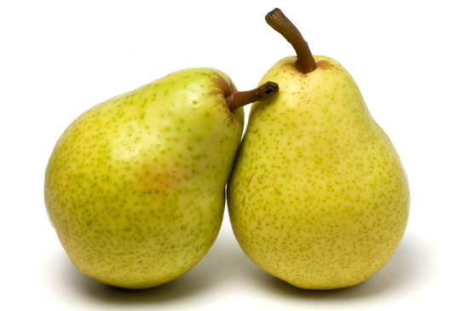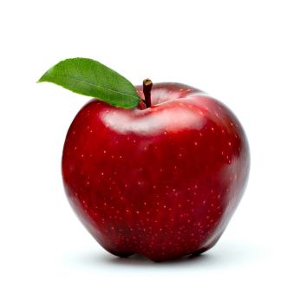

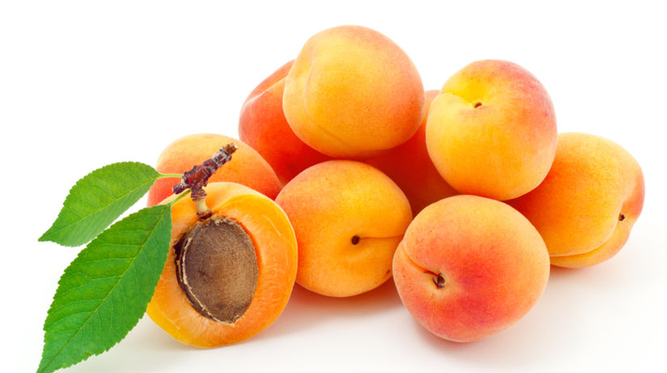

zeleninu

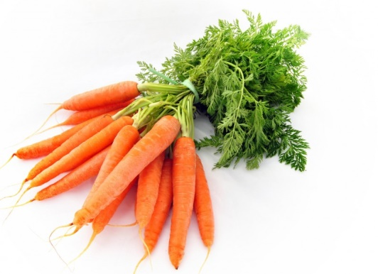 [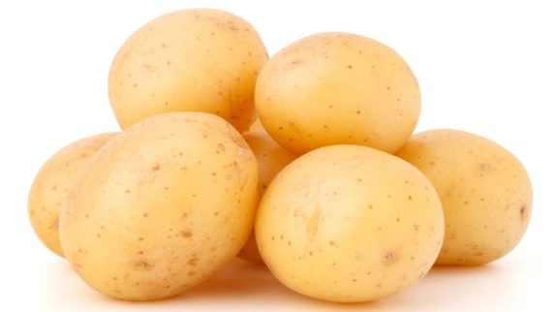](https://www.google.sk/url?sa=i&url=https://zdravie.pravda.sk/zdrava-vyziva/clanok/492078-pat-faktov-o-zemiakoch-pre-toto-su-zdrave/&psig=AOvVaw04j7tNNCjKn2IZnqwHiO6d&ust=1590486473070000&source=images&cd=vfe&ved=0CAIQjRxqFwoTCNiVwYHezukCFQAAAAAdAAAAABAD)

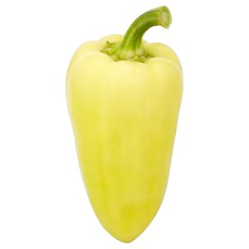

múku mäso

[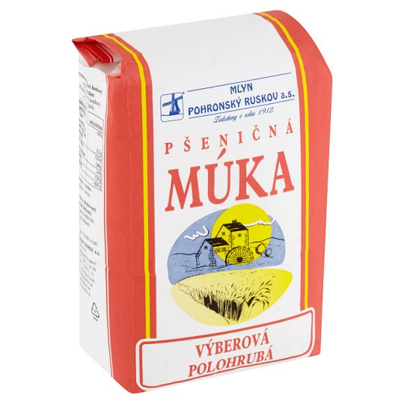](https://www.google.sk/url?sa=i&url=https://potravinydomov.itesco.sk/groceries/sk-SK/products/2002017045584&psig=AOvVaw1D3FNEIdgTZJEsCocQFBwH&ust=1590486625733000&source=images&cd=vfe&ved=0CAIQjRxqFwoTCNCJ1MvezukCFQAAAAAdAAAAABAD) [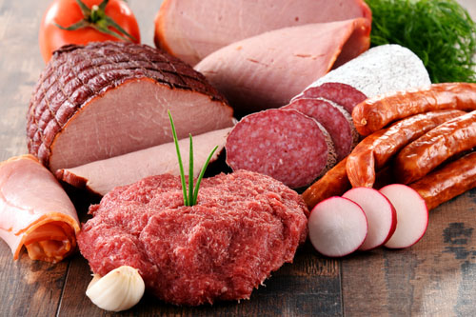](https://www.google.sk/url?sa=i&url=https://www.vitarian.sk/clanky/vyziva/2015/maso-a-riziko-rakoviny&psig=AOvVaw0eRtHj2XgGm3rGrnV9Ubqg&ust=1590486697508000&source=images&cd=vfe&ved=0CAIQjRxqFwoTCNjGqPPezukCFQAAAAAdAAAAABAJ)

Na metre kupujeme:

látky koberce

[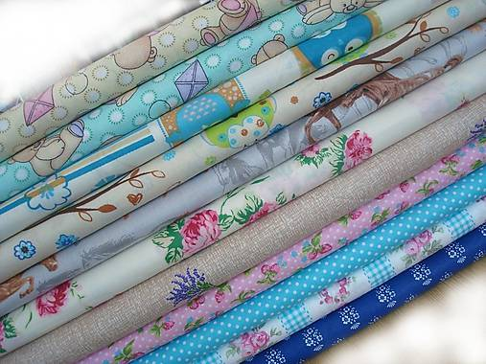](https://www.google.sk/url?sa=i&url=https://www.sashe.sk/Tovagli/detail/latka-modrotlac&psig=AOvVaw1I7mBqfa4kYvrZ8DcFSppG&ust=1590486888936000&source=images&cd=vfe&ved=0CAIQjRxqFwoTCPjBu8TfzukCFQAAAAAdAAAAABAI) [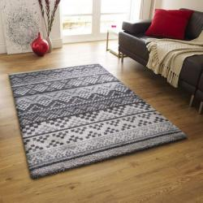](https://www.google.sk/url?sa=i&url=https://www.shopalike.sk/bytove-doplnky/bytovy-textil/koberce/moderne-koberce/hneda/&psig=AOvVaw1nvs4D5COpQEVDoKwQJqyi&ust=1590487028355000&source=images&cd=vfe&ved=0CAIQjRxqFwoTCOjwnPLhzukCFQAAAAAdAAAAABAJ)

závesy záclony

[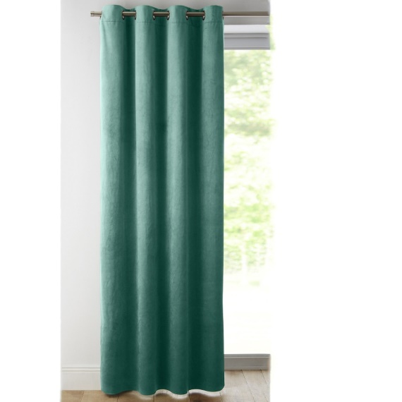](https://www.google.sk/url?sa=i&url=https://www.blancheporte.sk/zatemnovacie-zavesy-velur-17789.html&psig=AOvVaw1PZDDRfCLU0Aw8AVmN-ldB&ust=1590487582810000&source=images&cd=vfe&ved=0CAIQjRxqFwoTCMDovJjizukCFQAAAAAdAAAAABAQ)[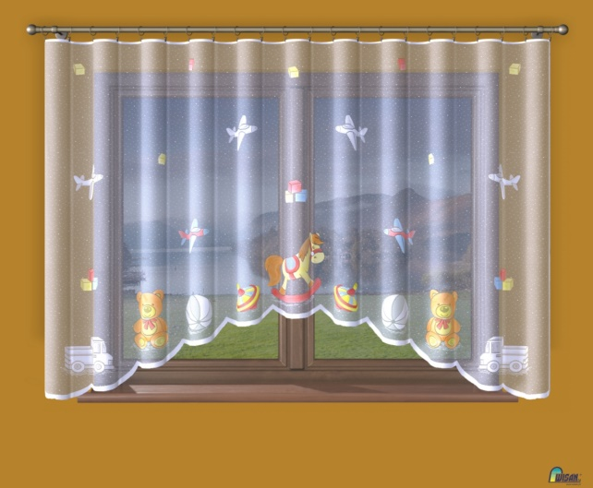](https://www.google.sk/url?sa=i&url=https://unitex.sk/sk/produkt/hotova-zakarova-detska-zaclona-konik&psig=AOvVaw1Q-4iYP2Hkil6RT8OgpWeq&ust=1590487972164000&source=images&cd=vfe&ved=0CAIQjRxqFwoTCJinldnjzukCFQAAAAAdAAAAABAS)

Na litre kupujeme:

olej mlieko malinovku sirup

[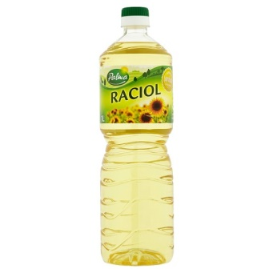](https://www.google.sk/url?sa=i&url=https://potravinydomov.itesco.sk/groceries/sk-SK/products/2002120203085&psig=AOvVaw1sxI2LpYNrp8N0JBnILj7f&ust=1590490529707000&source=images&cd=vfe&ved=0CAIQjRxqFwoTCMCfto_tzukCFQAAAAAdAAAAABAP)[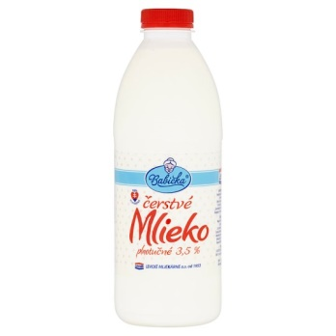](https://www.google.sk/url?sa=i&url=https://potravinydomov.itesco.sk/groceries/sk-SK/products/2002121396176&psig=AOvVaw2cd50R7_axgMrxBc1KM-mm&ust=1590490621910000&source=images&cd=vfe&ved=0CAIQjRxqFwoTCKixi7jtzukCFQAAAAAdAAAAABAD)[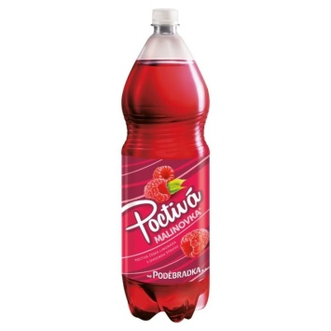](https://www.google.sk/url?sa=i&url=https://www.kosik.cz/produkt/podebradka-poctiva-malinovka-od&psig=AOvVaw1MmnDT9nAJA1ZZs4UeD8y_&ust=1590490660580000&source=images&cd=vfe&ved=0CAIQjRxqFwoTCMCo883tzukCFQAAAAAdAAAAABAD)[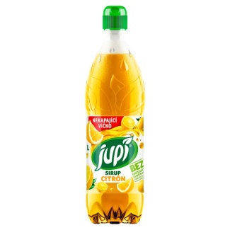](https://www.google.sk/url?sa=i&url=https://potravinydomov.itesco.sk/groceries/sk-SK/products/2002011579689&psig=AOvVaw0Ap65_4gf_d2tnyLv46AMx&ust=1590490776964000&source=images&cd=vfe&ved=0CAIQjRxqFwoTCOCchoTuzukCFQAAAAAdAAAAABAD)

benzín

[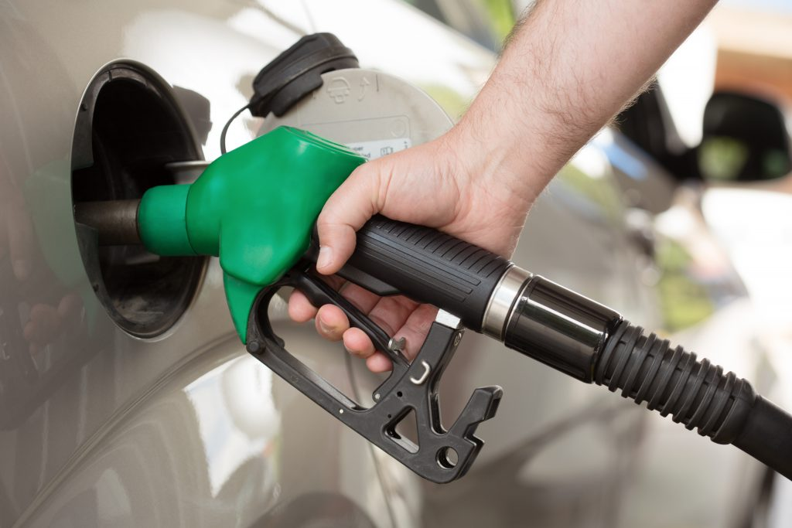](https://www.google.sk/url?sa=i&url=https://www.az-pneu.cz/clanky/benzin-nebo-diesel&psig=AOvVaw0AzkO1sXr6MASfBL0P-qWA&ust=1590492722030000&source=images&cd=vfe&ved=0CAIQjRxqFwoTCKD3saP1zukCFQAAAAAdAAAAABAD)

Na kusy kupujeme:

vajíčka rožky

[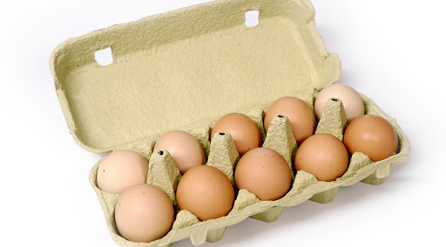](https://www.google.sk/url?sa=i&url=http://pdpanovce.sk/produkt/vajicka/&psig=AOvVaw3Itus50txmK1U1GRvtgWWp&ust=1590493892422000&source=images&cd=vfe&ved=0CAIQjRxqFwoTCIDix9T5zukCFQAAAAAdAAAAABAD) [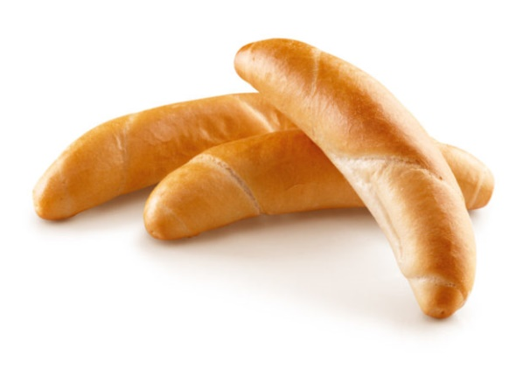](https://www.google.sk/url?sa=i&url=https://www.tovarapredaj.sk/2018/08/07/lidl-predava-v-72-svojich-obchodoch-uz-len-bezeckove-rozky/&psig=AOvVaw1JQCPLOjY4jHQPVxvwxXj_&ust=1590494002669000&source=images&cd=vfe&ved=0CAIQjRxqFwoTCLDMsIb6zukCFQAAAAAdAAAAABAD)

topánky hračky

[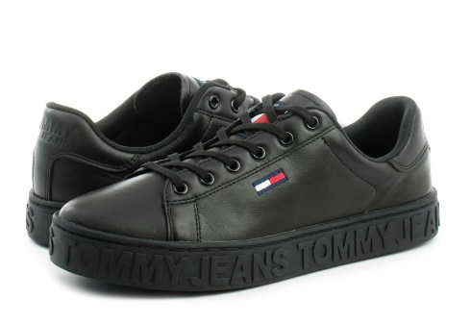](https://www.google.sk/url?sa=i&url=https://www.officeshoesonline.sk/topanky-tommy-hilfiger-topanky-jaz-1a/30020&psig=AOvVaw1soB2FchFQQeJAvOruhRNl&ust=1590494104249000&source=images&cd=vfe&ved=0CAIQjRxqFwoTCMjd4rj6zukCFQAAAAAdAAAAABAD) [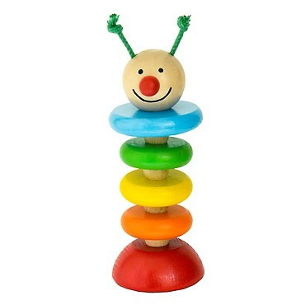](https://www.google.sk/url?sa=i&url=https://www.originalnehracky.sk/p/4799/drevene-hracky-hracky-pre-najmensich-detoa-husenica-na-gume&psig=AOvVaw335_I_eRlXbI2ctStSWoNq&ust=1590494314107000&source=images&cd=vfe&ved=0CAIQjRxqFwoTCMi_s8j7zukCFQAAAAAdAAAAABAH)[](https://www.google.sk/url?sa=i&url=https://www.mileobchod.sk/Zajac-28-cm-manuska-krtkovi-kamarati-d614.htm&psig=AOvVaw335_I_eRlXbI2ctStSWoNq&ust=1590494314107000&source=images&cd=vfe&ved=0CAIQjRxqFwoTCMi_s8j7zukCFQAAAAAdAAAAABAT)

V obchode môžeme platiť s peniazmi a s kreditnou kartou

mince

[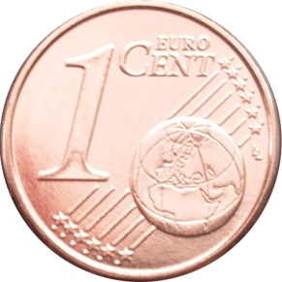](https://www.google.sk/url?sa=i&url=https://en.numista.com/catalogue/pieces56030.html&psig=AOvVaw14Cp_QHhLgN9_A2cimcIz5&ust=1590503541752000&source=images&cd=vfe&ved=0CAIQjRxqFwoTCPCGz8idz-kCFQAAAAAdAAAAABAd) [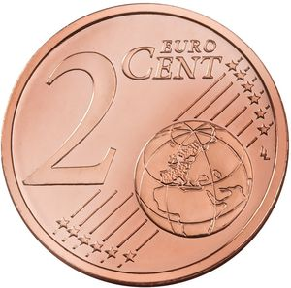](https://www.google.sk/url?sa=i&url=https://colnect.com/tl/coins/coin/52596-2_Euro_Cent-2015~Today_-_Euro_Circulation-Litwaniya&psig=AOvVaw3U8FlxULv05pWv6ih5UZQO&ust=1590503928756000&source=images&cd=vfe&ved=0CAIQjRxqFwoTCJiAiIGfz-kCFQAAAAAdAAAAABAJ)[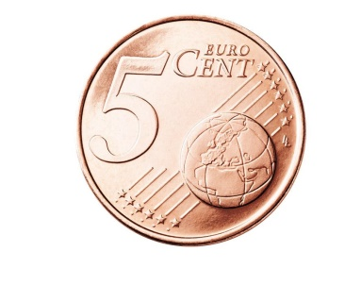](https://www.google.sk/url?sa=i&url=https://www.pinterest.com/luxeinmo/euro-monedas-money/&psig=AOvVaw2UM6b2IBim2nejfbBYR7Dg&ust=1590504037711000&source=images&cd=vfe&ved=0CAIQjRxqFwoTCJDPj7efz-kCFQAAAAAdAAAAABAJ)[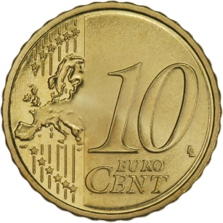](https://www.google.sk/url?sa=i&url=https://www.fleur-de-coin.com/coin-shop/Slovakia-10-cents-2009-Bratislava-Castle_eur2163&psig=AOvVaw35fViKrP0o5-Mp8uF2cr0K&ust=1590504208275000&source=images&cd=vfe&ved=0CAIQjRxqFwoTCNiv8oagz-kCFQAAAAAdAAAAABAD)

[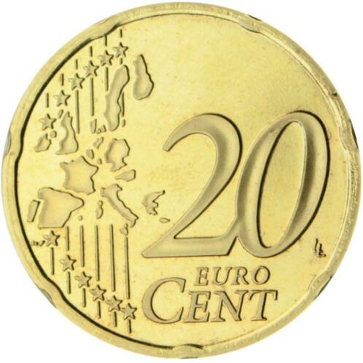](https://www.google.sk/url?sa=i&url=https://www.2dehands.be/a/postzegels-en-munten/munten-europa-euromunten/m1463763557-lyst-euromunten-20-cent-alle-jaren-landen-update-02-03-20.html&psig=AOvVaw1ANEMngx6XMydmrPCx64Ta&ust=1590504363637000&source=images&cd=vfe&ved=0CAIQjRxqFwoTCLCPrtCgz-kCFQAAAAAdAAAAABAU) [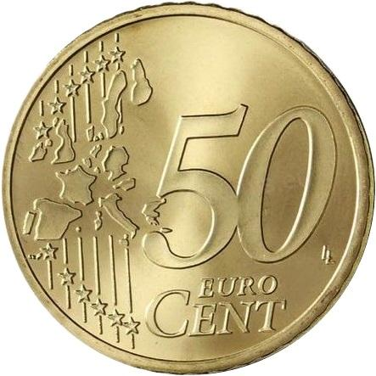](https://www.google.sk/url?sa=i&url=https://www.euronumis.eu/50-cent-2011-Finsko-ob-UNC-d10000.htm?tab%3Ddescription&psig=AOvVaw0GC7wt8m89UEAlavWwx90Q&ust=1590504795550000&source=images&cd=vfe&ved=0CAIQjRxqFwoTCMi9o56iz-kCFQAAAAAdAAAAABAJ)[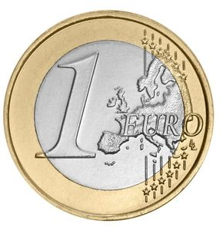](https://www.google.sk/url?sa=i&url=https://colnect.com/sk/coins/coin/23869-1_Euro-Euro_set-Est%C3%B3nsko&psig=AOvVaw3-32vKHWLO5uUraUv8tsnq&ust=1590504849727000&source=images&cd=vfe&ved=0CAIQjRxqFwoTCOCZiLiiz-kCFQAAAAAdAAAAABAD)[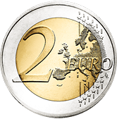](https://www.google.sk/url?sa=i&url=https://www.nbs.sk/en/banknotes-and-coins/euro-coins/circulation-coins/common-sides-of-euro-circulation-coins&psig=AOvVaw3elXfxewLFw9QehY8mh5uF&ust=1590504908375000&source=images&cd=vfe&ved=0CAIQjRxqFwoTCLCssNSiz-kCFQAAAAAdAAAAABAR)

bankovky

[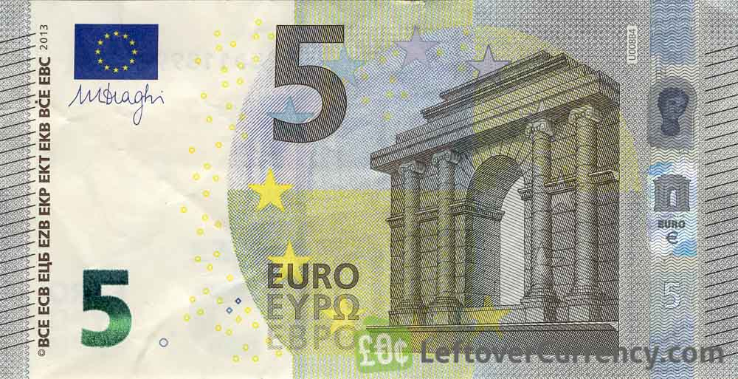](https://www.google.sk/url?sa=i&url=https://www.leftovercurrency.com/exchange/euros/current-euro-banknotes/5-euros-banknote-second-series/&psig=AOvVaw2NRN-riAAB2aDRdu2LVAEF&ust=1590505134457000&source=images&cd=vfe&ved=0CAIQjRxqFwoTCKDY57-jz-kCFQAAAAAdAAAAABAJ) [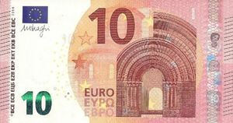](https://www.google.sk/url?sa=i&url=https://colnect.com/en/banknotes/banknote/52210-10_Euro-2013-2015_Issue-Euro&psig=AOvVaw1ZYodImLSAd0-_P2-pclqw&ust=1590505438992000&source=images&cd=vfe&ved=0CAIQjRxqFwoTCLCk7takz-kCFQAAAAAdAAAAABAD)

[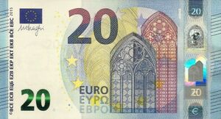](https://www.google.sk/url?sa=i&url=https://colnect.com/en/banknotes/banknote/64606-20_Euro-2013-2019_Europa_Issue-Euro&psig=AOvVaw1HaL7A0LWFsejPLu-RNCjq&ust=1590505487117000&source=images&cd=vfe&ved=0CAIQjRxqFwoTCJC60Oikz-kCFQAAAAAdAAAAABAD) [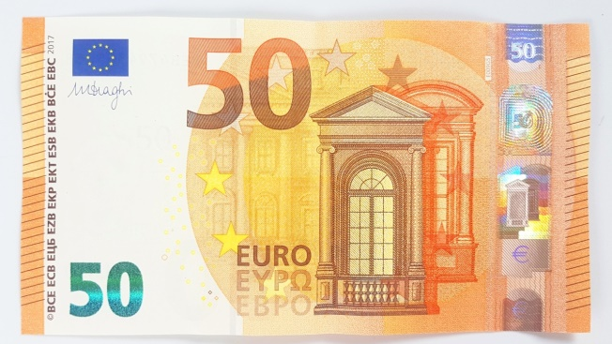](https://www.google.sk/url?sa=i&url=https://dollarsbills.com/product/buy-fake-euro-notes/&psig=AOvVaw3A0XvjypwpYPB4oROlIAu6&ust=1590505552735000&source=images&cd=vfe&ved=0CAIQjRxqFwoTCNjxhZSlz-kCFQAAAAAdAAAAABAZ)

[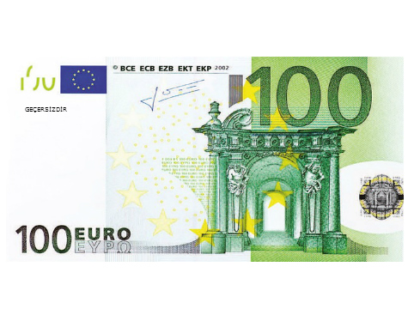](https://www.google.sk/url?sa=i&url=https://www.bolmarka.com/saka-parasi-100-adet-100-euro&psig=AOvVaw1EmZCMtpc1e2_nE6bzbDvk&ust=1590505798699000&source=images&cd=vfe&ved=0CAIQjRxqFwoTCMCprP-lz-kCFQAAAAAdAAAAABAW) [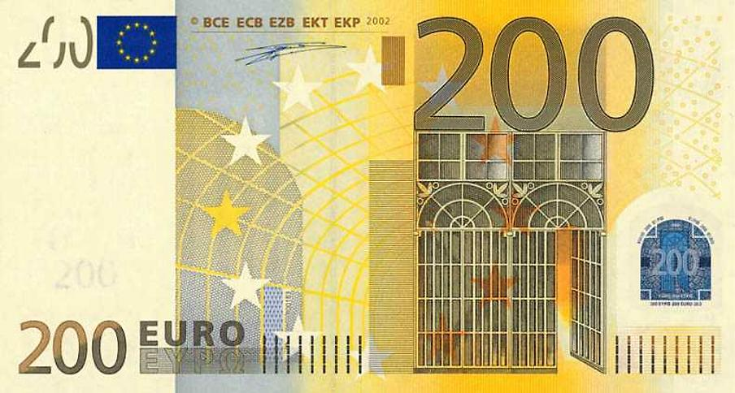](https://www.google.sk/url?sa=i&url=http://www.bratislavaflats.com/kniznica-library/mena-currency/200-euro.html&psig=AOvVaw32l2psImcVB1j4M8yKbglb&ust=1590506855988000&source=images&cd=vfe&ved=0CAIQjRxqFwoTCKiS1_apz-kCFQAAAAAdAAAAABAD)

[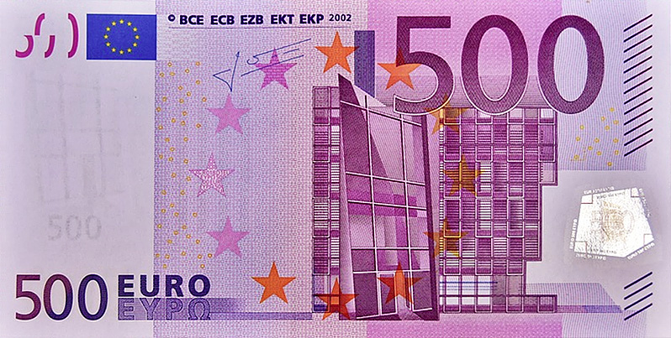](https://www.google.sk/url?sa=i&url=https://numismag.com/en/2019/01/06/the-end-of-the-500-euro-banknote-for-january-2019/&psig=AOvVaw0oAih0z1J0hkcLU_9r0LRh&ust=1590507045530000&source=images&cd=vfe&ved=0CAIQjRxqFwoTCJD2huiqz-kCFQAAAAAdAAAAABAE)