Meno a priezvisko: _______________________________________________________

Trieda: ________

***1. Vylúšti tajničku***

|  |  |  |  |  |  |  |  |
| --- | --- | --- | --- | --- | --- | --- | --- |
| 1 |  |  |  |  |  |  |  |
| 2 |  |  |  |  |  | | | |
| 3 |  |  |  | | | | | |
| 4 |  |  |  |  |  |  | | |
| 5 |  |  |  |  | | | | |
| 6 |  |  |  |
| 7 |  |  |  |  |  |  | | |
| 8 |  |  |  | | |
| **Y** |  | | | | | | | |

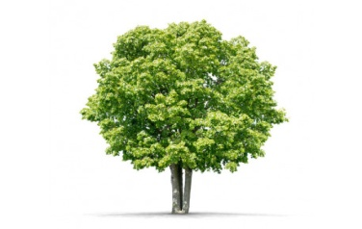 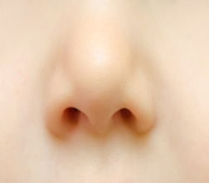 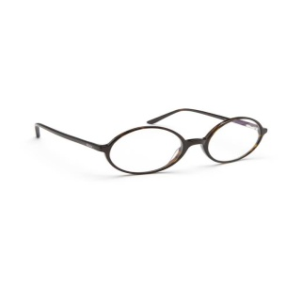 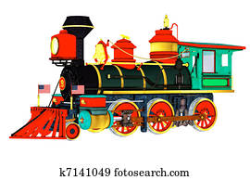

5

6

1

2

8...

4.. ..

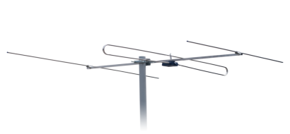 

3

7